- Write a Java function to implement binary search.
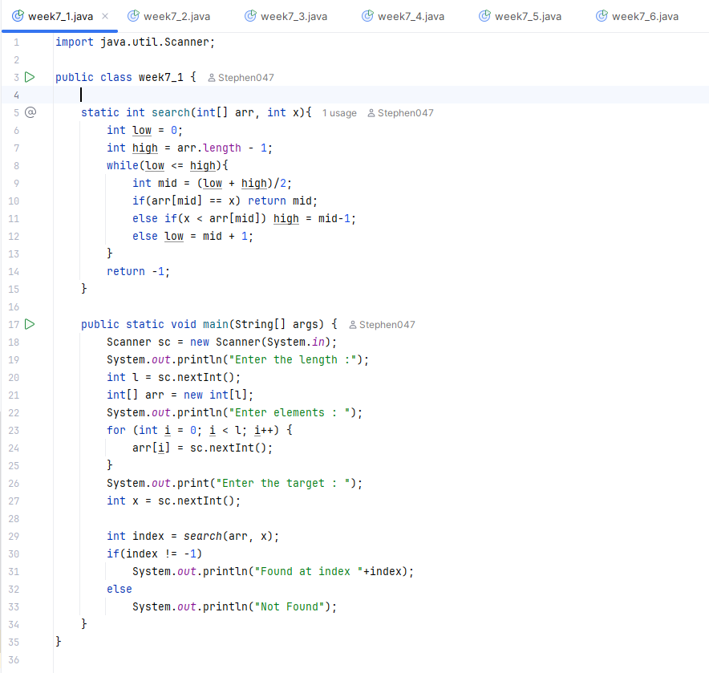
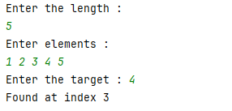
- Write a Java function to arrange the elements of an array in ascending order (Sorting).
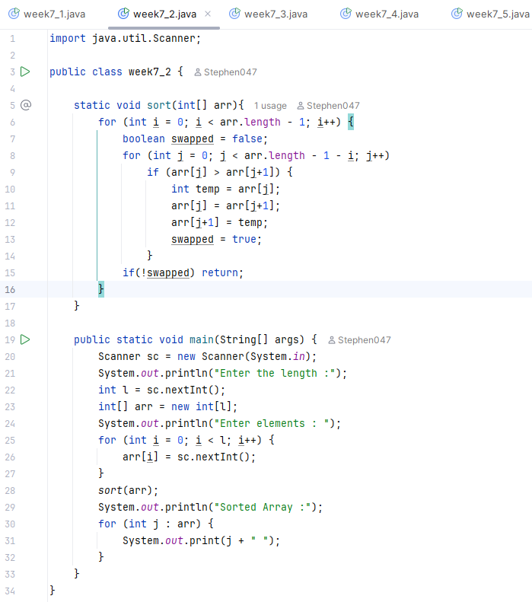
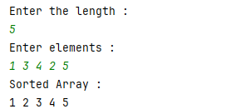
- Write a program to reverse a given string.
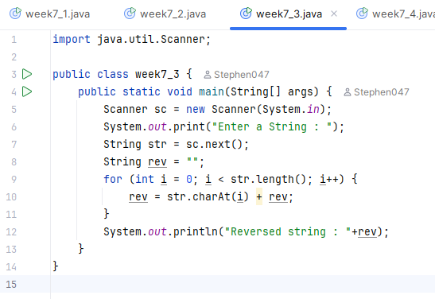
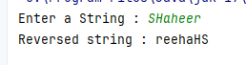
- Write a program to check whether a given string is palindrome or not.
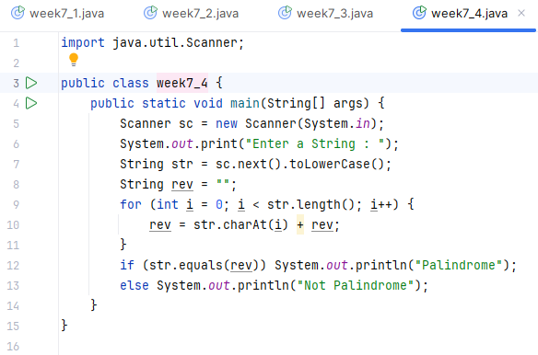
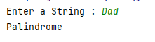
- Write a program to implement factorial of a number through recursion.
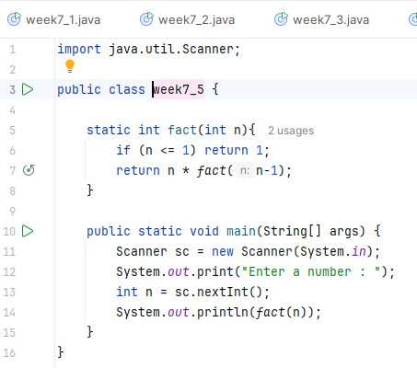
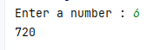
- Write a program to implement Fibonacci series of a number with and without recursion.
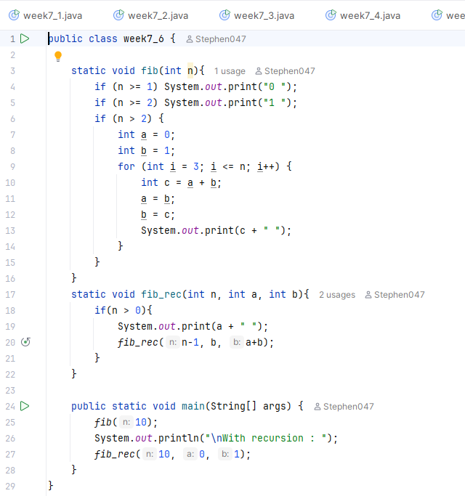
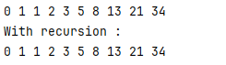
- Write a Java function to find the greatest common divisor (GCD) of two numbers with and without using recursion.
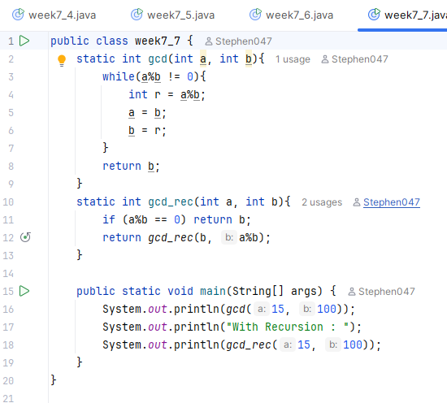
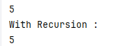
- Write a program to check whether two strings are anagrams of each other (“listen” and “silent” are anagrams).
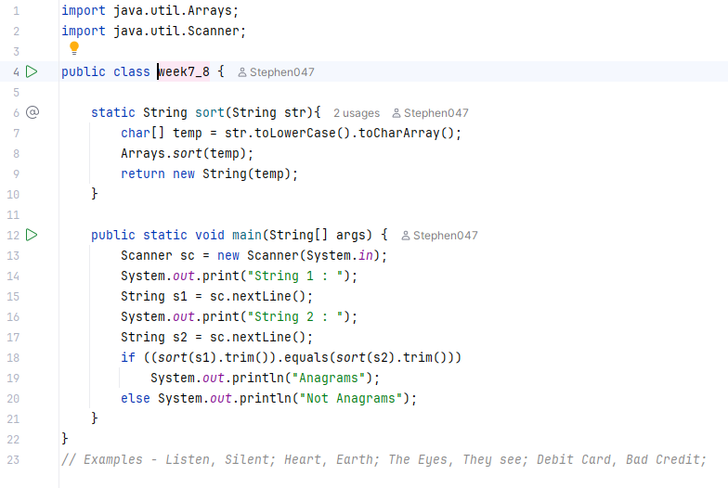
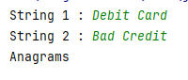
- Implement quick sort using recursion.
